A vision for the Great Birrarung Lands: a discussion paper prepared by the Birrarung Council.
‘The River needs its lands’
inspired by Aunty Margaret Gardiner, Wurundjeri Elder
The Birrarung needs its lands, like we need water.
Without water, there is no life,
without its lands, there is no Birrarung.
The River needs its lands.
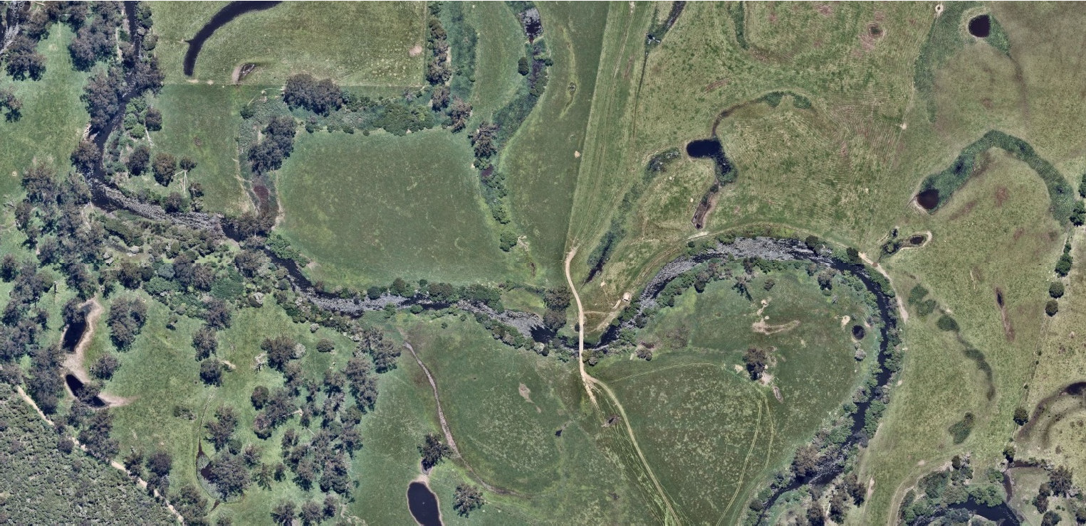
‘The River needs its lands’ reflects the connection between spirit and place.
Birrarung is more than just water. It is the layers in the landscape that the River has formed, the soils, the trees, the plants, and the animals. It is the stories and layers of history that live within this landscape and the new stories and layers that unfold as we flow like the River through time.

Introduction
This paper has been prepared by the Birrarung Council to initiate a dialogue about how we might envision the Great Birrarung Lands. Our objective is to prompt thinking in a way that brings together our understanding of the River and its lands as a single living entity, and a significant natural and cultural landscape,
Our aspiration for the Great Birrarung Lands is a valued and nurtured natural and cultural landscape, consisting of all of land uses and tenures, unified by a shared love and respect for the Birrarung as a living entity.
The Great Birrarung Lands are not defined by the ‘colonial’ boundaries of land titles and land use, instead encompassing the ways of life and land use linked to the River, consistent with its living entity status. They include ‘Birrarung Parklands’ envisioned in Burndap Birrarung Burndap Umarkoo - Yarra Strategic Plan 2022-2032 and the Greater Yarra Urban Parkland enacted by the Yarra River Protection (Wilip-gin Birrarung murron) Act 2017 as well as private land.

Definitions
Great Birrarung Lands – the Birrarung Council’s vision for a world class natural and cultural landscape encompassing all lands belonging to the River
Greater Yarra Urban Parklands – gazetted parkland as defined under the Yarra River Protection (Wilip-gin Birrarung murron) Act 2017
Birrarung Parkland – Burndap Birrarung Burndap Umarkoo vision for public parkland associated with the Yarra River corridor

The 50 Year Community Vision
The Birrarung is ‘one living integrated natural entity’ and all Birrarung land and water - from the source to the sea - should be recognised as part of the one living natural entity in line with the 50-year Community Vision from Burndap Birrarung Burndap Umarkoo: -

Our Yarra River, Birrarung, is recognised around the world as an iconic example of a nurturing relationship between a river and its community.
Flowing from source to sea, it is the resilient lifeblood of past, present and future generations of Victorians. It connects and enriches our flourishing city, suburbs, regions and beyond.
Our Yarra River, Birrarung, its essential role in our lives and its rich history, are respected, understood and protected. It has cared for us for thousands of years and will for thousands to come.
The vital and continued role of Traditional Owners as custodians of the River, and its role in their culture, is recognised and celebrated.
Our Yarra River, Birrarung and its diverse surrounding landscapes provide a place of refuge, recreation, learning and livelihood. It brings communities together and supports sustainable local economies.
Its clean waters and connected network of thriving green spaces nurture biodiversity and deepen the relationship between people and nature.
Our Yarra River, Birrarung is respected as a sacred natural living entity, and everyone takes responsibility for its care. Its health and integrity are paramount and uncompromised.

The Great Birrarung Lands
The Great Birrarung Lands is a natural and cultural landscape treasured by Victorians. The Yarra River (Birrarung) is at the heart of the Great Birrarung Lands, weaving through the landscape it created, connecting communities, histories, activities, culture, art and landscape into one natural, living entity. The River links the mountains to the sea, the city to nature and all of us to a rich cultural history that flows tens of thousands of years back in time.
Birrarung is central to the Wurundjeri Woi-wurrung People’s identity; it forms part of their Dreaming. A life source, the relationships between the Wurundjeri Woi-wurrung People and Birrarung are layered – spiritual, ancestral, social, cultural, and economic.
Birrarung has shaped Country and the Wurundjeri Woi-wurrung world view. Birrarung has also shaped urban Melbourne, while the city and its surroundings have transformed the River.
The Great Birrarung Lands consists of all land along the River. This goes beyond urban and bushland parks and includes private property, public roads and the like. Private property may include – for example – land used for agriculture, industry, commerce, educational institutions, sports clubs, residences or conservation. Irrespective of land use, all adjacent land contributes to the pulse of the River as a living entity and therefore, to the Great Birrarung Lands.

The Wurundjeri Woi-wurrung People and the community share the desire for a balance between community access to the River and its land, and the need for conservation. The Great Birrarung Lands would support the natural values of our River, whilst maintaining a diversity of land uses and experiences that link people to the River. Stronger nature- and culture-based infrastructure would strengthen the connection. Community infrastructure, such as education hubs and trails, would help create a broader identity for public parks within the Great Birrarung Lands.
Shared value and appreciation of Birrarung and its lands would build positive and nurturing stewardship of land linked to the River. We invite the custodians, owners and managers of the Great Birrarung Lands (urban and rural) to engage and contribute to this concept as it continues to form.
Some of the initial steps would focus on:
- Creating a stronger identity for Birrarung and its land locally, nationally, and internationally through the identity of the Great Birrarung Lands
- Recognising, protecting and celebrating the landscape character of the River corridor
- Strengthen the role of Traditional Owner custodianship of the Great Birrarung Lands.
- Integrating and aligning stewardship of, and investment in, lands in the Birrarung corridor consistent with the status of the River as a ‘single living entity’.
- In public parklands, integrating and aligning investment and stewardship to achieve an appropriate balance between use and enjoyment of the parkland and conservation of the environment, having regard to the River as a ‘single living entity’
- Integrating place-based stories and culture into low-impact, infrastructure and design that enables Net Gain for the River.
- Recognise the land along the river in the Planning Scheme for its landscape character and contributions to the river including Net Gain for the Birrarung
- Continue with the current program of incorporating land identified in existing overlays for inclusion in Yarra urban parklands.

The Journey ahead
The Birrarung Council’s aspiration for the Great Birrarung Lands sets an ambitious agenda requiring the involvement and commitment of all who engage with Birrarung, particularly custodians, owners and managers. As the ‘voice for the River’, we will continue to prompt discussion about the Great Birrarung Lands and understand that the concept will evolve with more voices involved. We will continue with the current program of incorporating land identified in existing overlays for inclusion in Yarra urban parklands.
Our concern is to stimulate positive change in how the River and its lands are appreciated and ultimately cared for in a way that nurtures the connection between the River and its lands and reflects the layers of history that live within this landscape consistent with the Burndap Birrarung burndap umarkoo and 50-year Community Vision.

